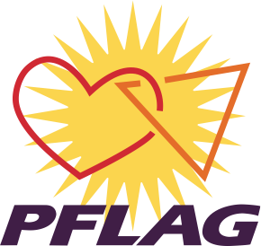

OHIO NONVIOLENCE PARADE & RALLY
Sunday, October 7, 2018
3 PM
Gather at Wick & Wood Streets

PLEASE JOIN YOUNGSTOWN AREA PFLAG
as we parade with other Youngstown organizations
in support of Ohio Nonviolence Week
SEE YOU THERE!
Bring your signs of support.

